Day 32 - 28th Aug 2026 - Happy Rakhi!

Task 1:

☁️ Introduction to Cloud Computing Concepts
- Question: How does cloud computing differ from traditional on-premises IT infrastructure in terms of scalability and cost management?

🌍 AWS Global Infrastructure (Regions & Availability Zones)
- Question: Why is it important to deploy applications across multiple Availability Zones within a region?

🔐 Identity and Access Management (IAM)
- Question: What is the principle of “least privilege” in IAM, and why is it critical for cloud security?

💻 EC2 – Compute Basics
- Question: How does Amazon EC2 enable elasticity in application workloads compared to physical servers?

📦 S3 – Storage Basics
- Question: Why is Amazon S3 considered “object storage,” and how does it differ conceptually from block storage?

🌐 VPC – Networking Basics
- Question: What role does a subnet play in a VPC, and how does it affect the accessibility of resources?

🗄️ RDS – Managed Database Basics
- Question: How does Amazon RDS reduce the operational burden of database management compared to self-hosted databases?

🔒 Security Groups & Basic Cloud Security
- Question: How do security groups function as virtual firewalls, and why are they stateful?

🖥️ AWS CLI & Console Basics
- Question: What are the advantages of using the AWS CLI over the AWS Management Console for managing resources?

9.15 to 9.35

Open your logins – provided in AWS details file.

Task 2:

Go to all services

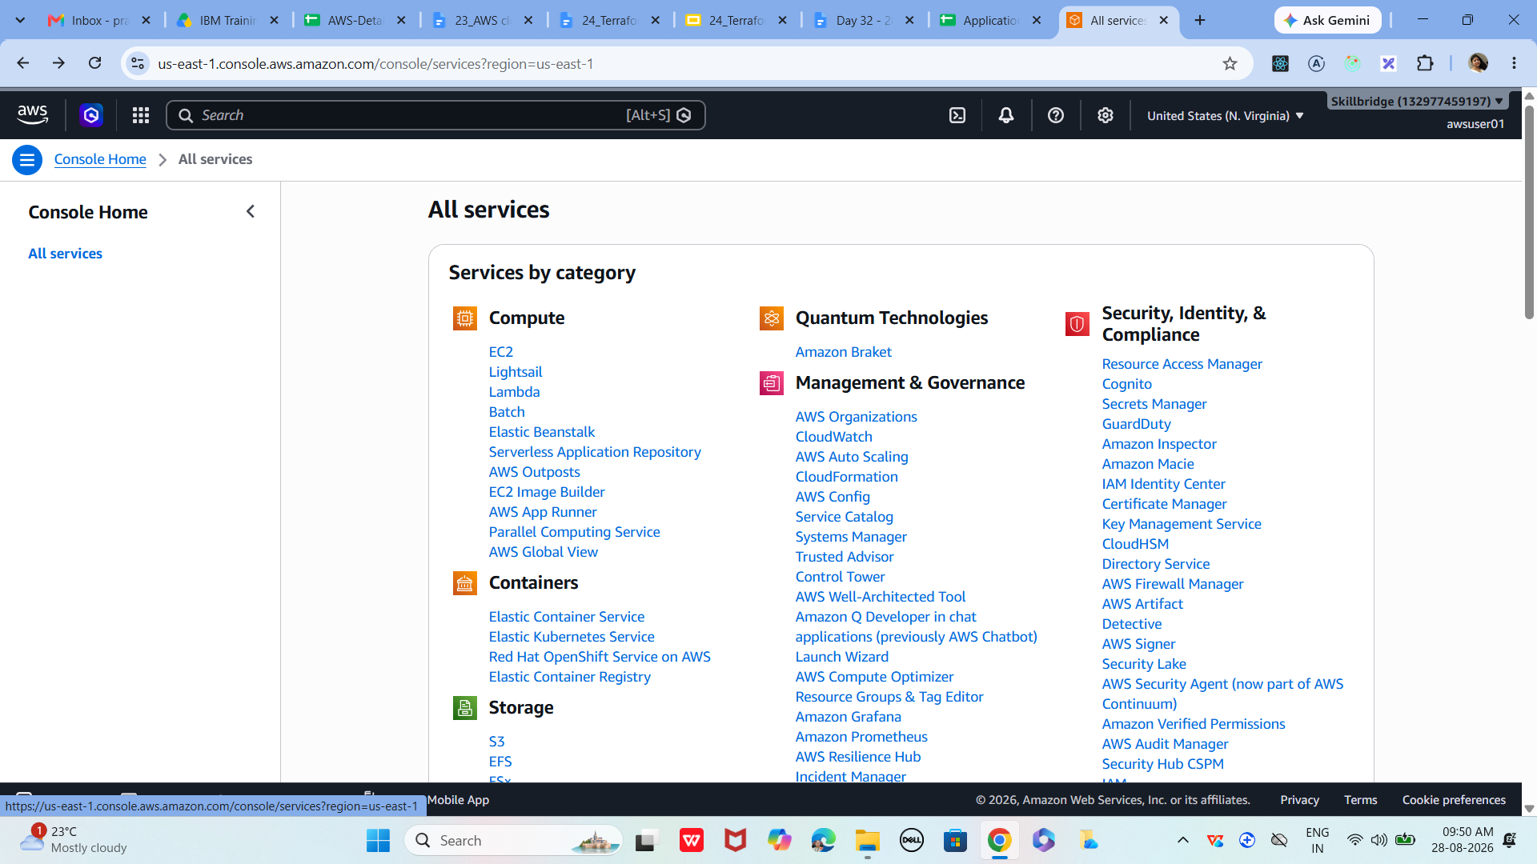

Task 3:

AWS Global Infrastructure
Get familiar with AWS regions and availability zones.
- Log in to AWS Console
- Navigate to Services → EC2 → Regions dropdown
- Identify your nearest region (e.g., ap-south-1 for Mumbai)
- Note that each region has multiple AZs for redundancy

Task 4:

Now lets create EC2 instance …

step 01
Log in to AWS Console

Ensure you are in the correct Region (top-right corner)
EC2 resources are region-specific

step 02
Navigate to EC2 Service
eC2 is Amazon’s compute service for virtual servers.

From Console → Services → EC2

Click EC2 under Compute section

This opens the EC2 Dashboard

step 03
Launch Instance Wizard
The wizard guides you through configuration.

Click Launch Instance

Provide a name for your instance (e.g., PrasunambaEC2)

step 04
Choose Amazon Machine Image (AMI)
AMI defines the operating system and base software.

Select Amazon Linux 2 or Ubuntu for beginners

Each AMI comes preconfigured with OS and packages

step 05
Select Instance Type
Defines CPU, memory, and performance.

Choose t2.micro (Free Tier eligible)

good for testing and small workloads

step 06
Configure Key Pair
Key pairs allow secure SSH login.

Create a new key pair if you don’t have one

Download the .pem file and keep it safe (if you want to access your instance next time)

Without this, you cannot access your instance
This is my keypair
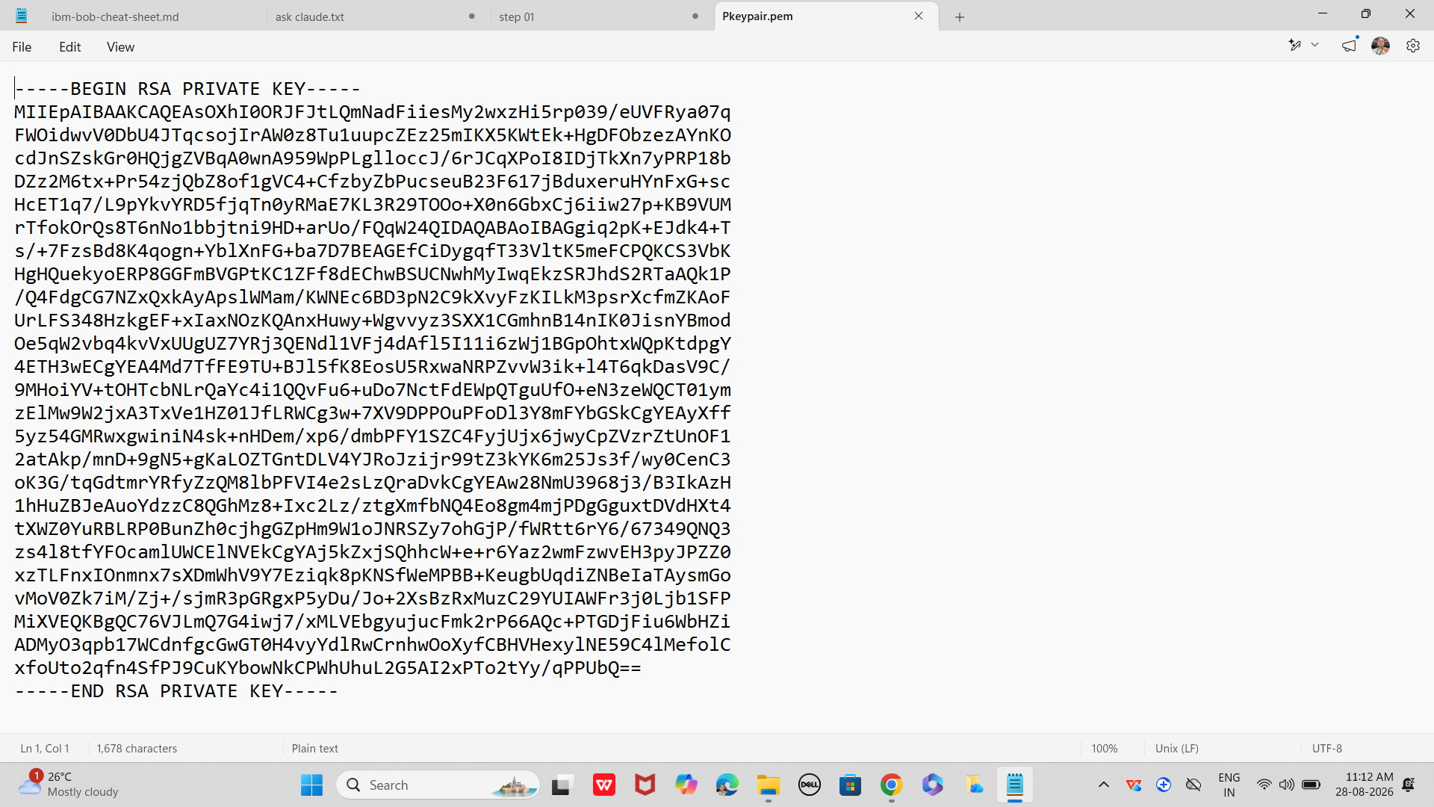

step 07
Set Network Settings
Networking controls how your instance connects.

Default VPC is fine for you as u r beginners

Enable Auto-assign Public IP for internet access

Security Group: allow SSH (22), HTTP (80) if hosting a web app

step 08
Configure Storage
Define disk size and type.

Default 8 GB is fine for testing as of now

Increase if you plan to store more data

step 09
Review and Launch
Finally check before provisioning.

Review all settings

Click Launch Instance

Wait for status to show Running

step 10
now
Connect to Instance
Access your server via SSH.

On terminal: ssh -i key.pem ec2-user@<Public-IP>

Replace <Public-IP> with your instance’s public IP

Ensure .pem file permissions are set: chmod 400 key.pem

You are now inside your EC2 server
—------------------------------------------------------------------------

Task 5:

Create a directory in
step 01
Go to AWS Management Console
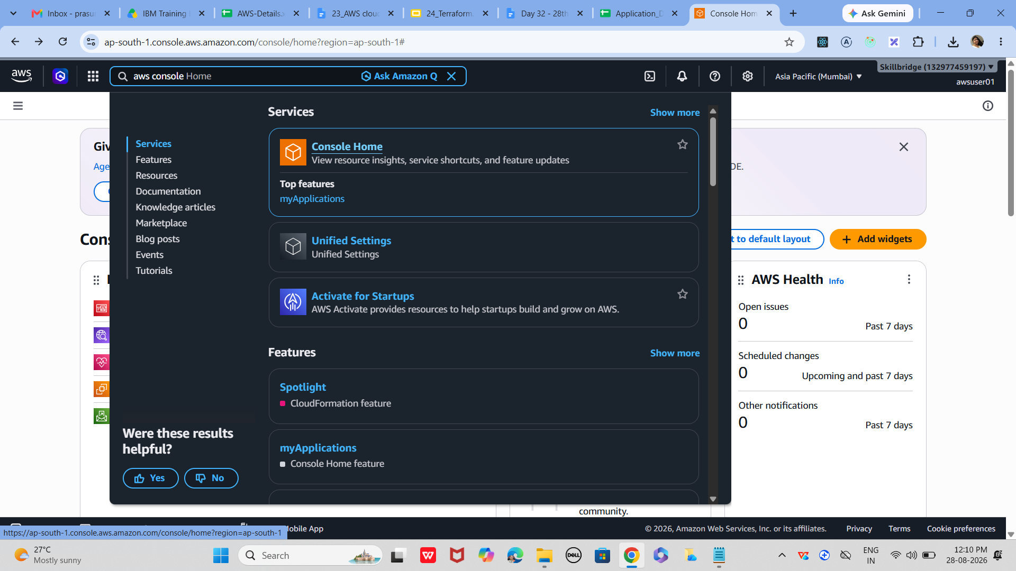
Navigate to Directory Service → Cloud Directory
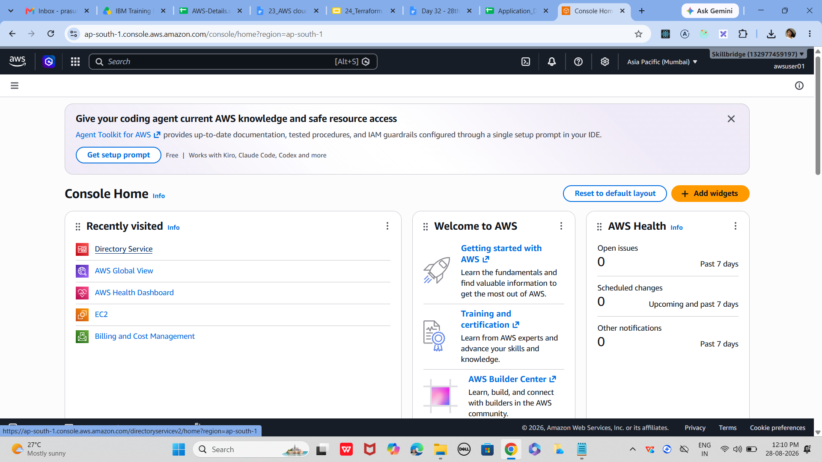

02
Choose Set Up Cloud Directory
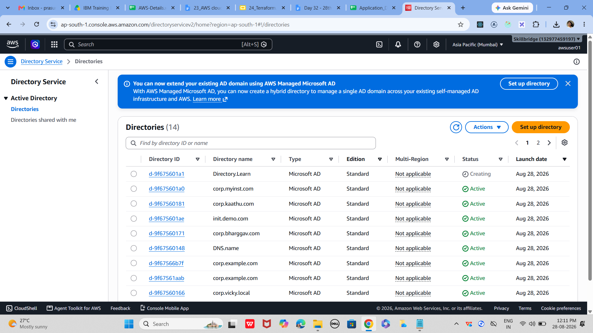

This option allows you to create a new directory.
In the navigation pane, select Directories
Click Set up Cloud Directory

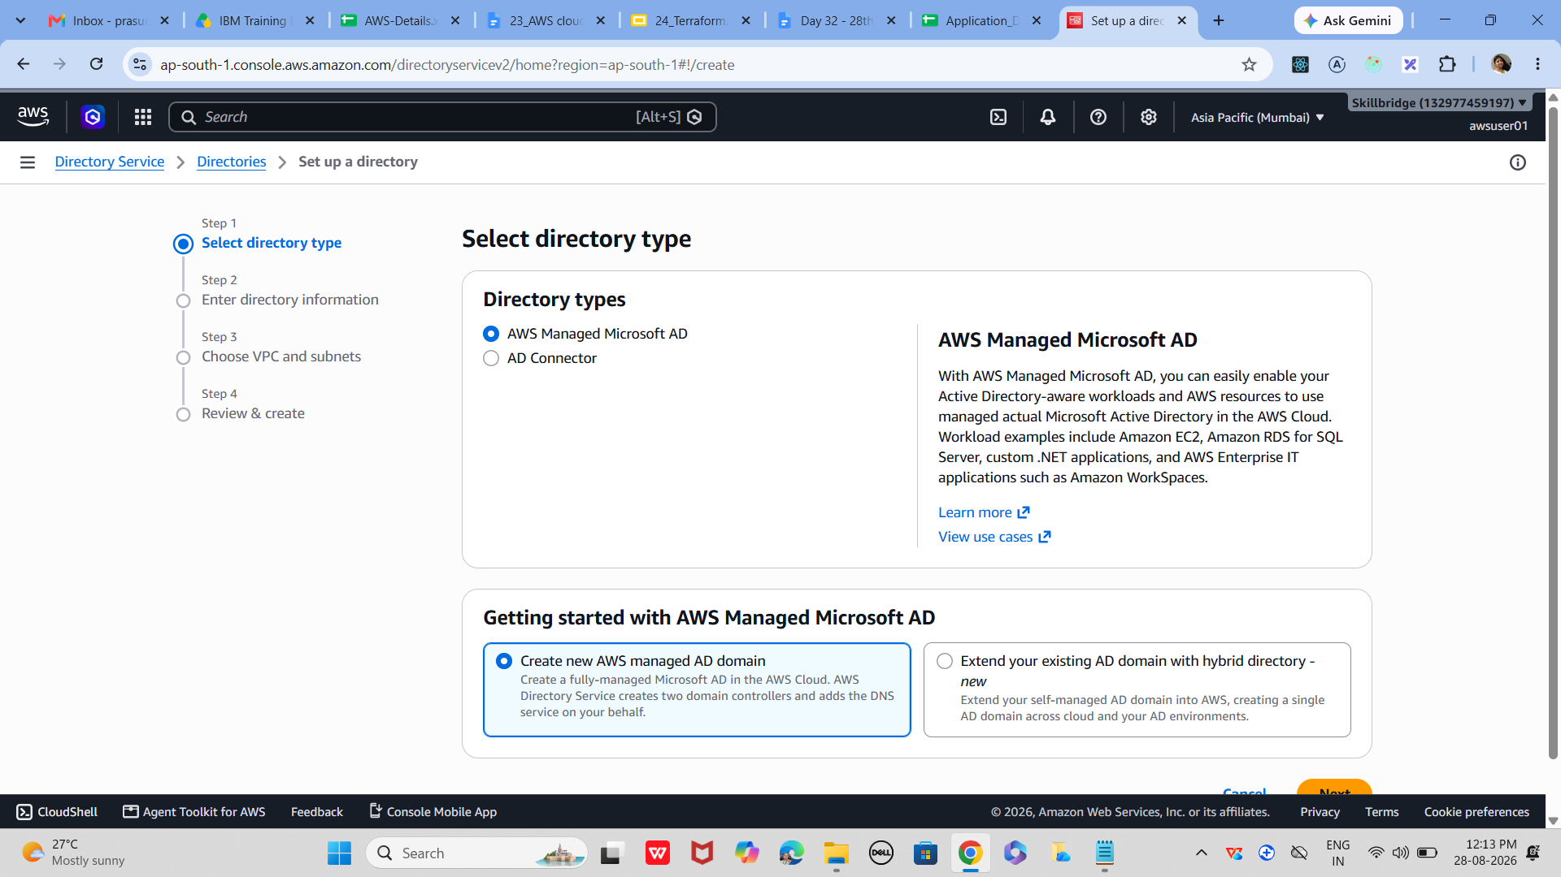

03
Select a Schema
Mandatory
A schema defines the structure of your directory.
Choose one of the following:
Managed schema (predefined by AWS)
Sample schema (templates provided by AWS)
Custom schema (your own design)
Ensure schema is in Published state before applying

04
Name Your Directory
Give your directory an identifiable name.
Enter a name such as UserRepository or CorpDirectory
Confirm schema selection

05
Review and Create
Finalize the setup and deploy the directory.
Review directory details
Click Create to publish and activate the directory

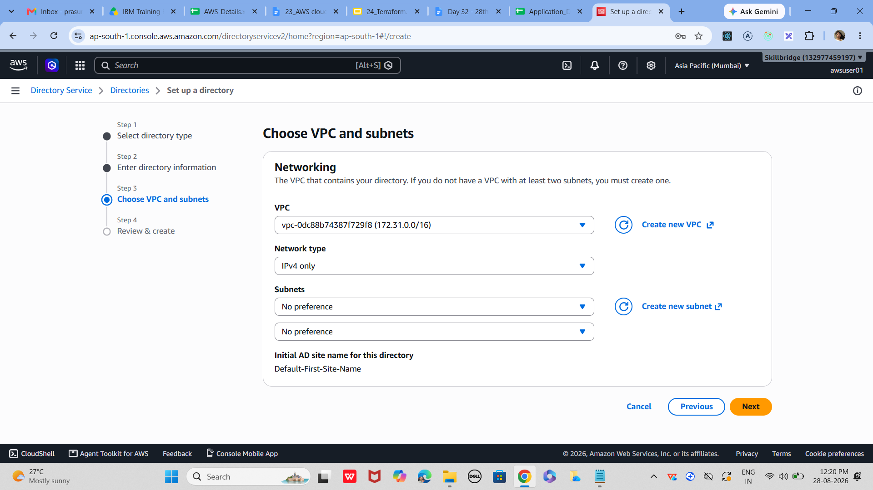

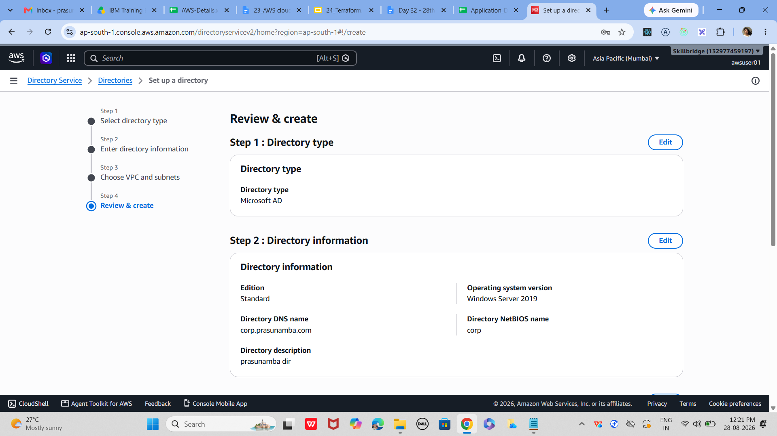

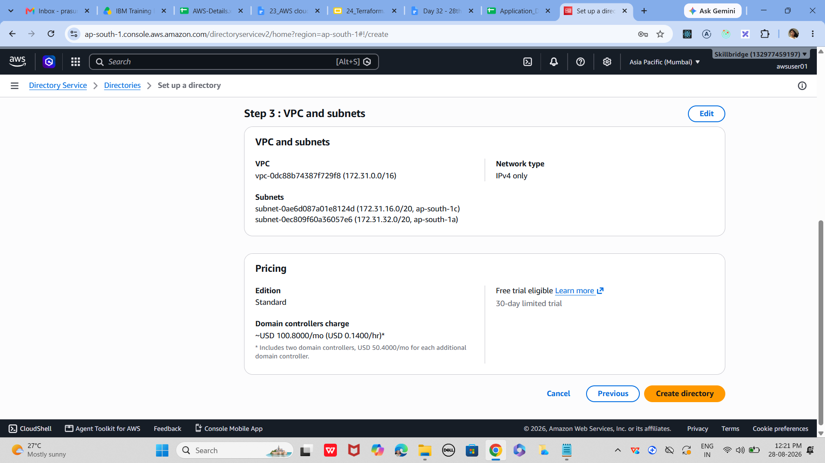

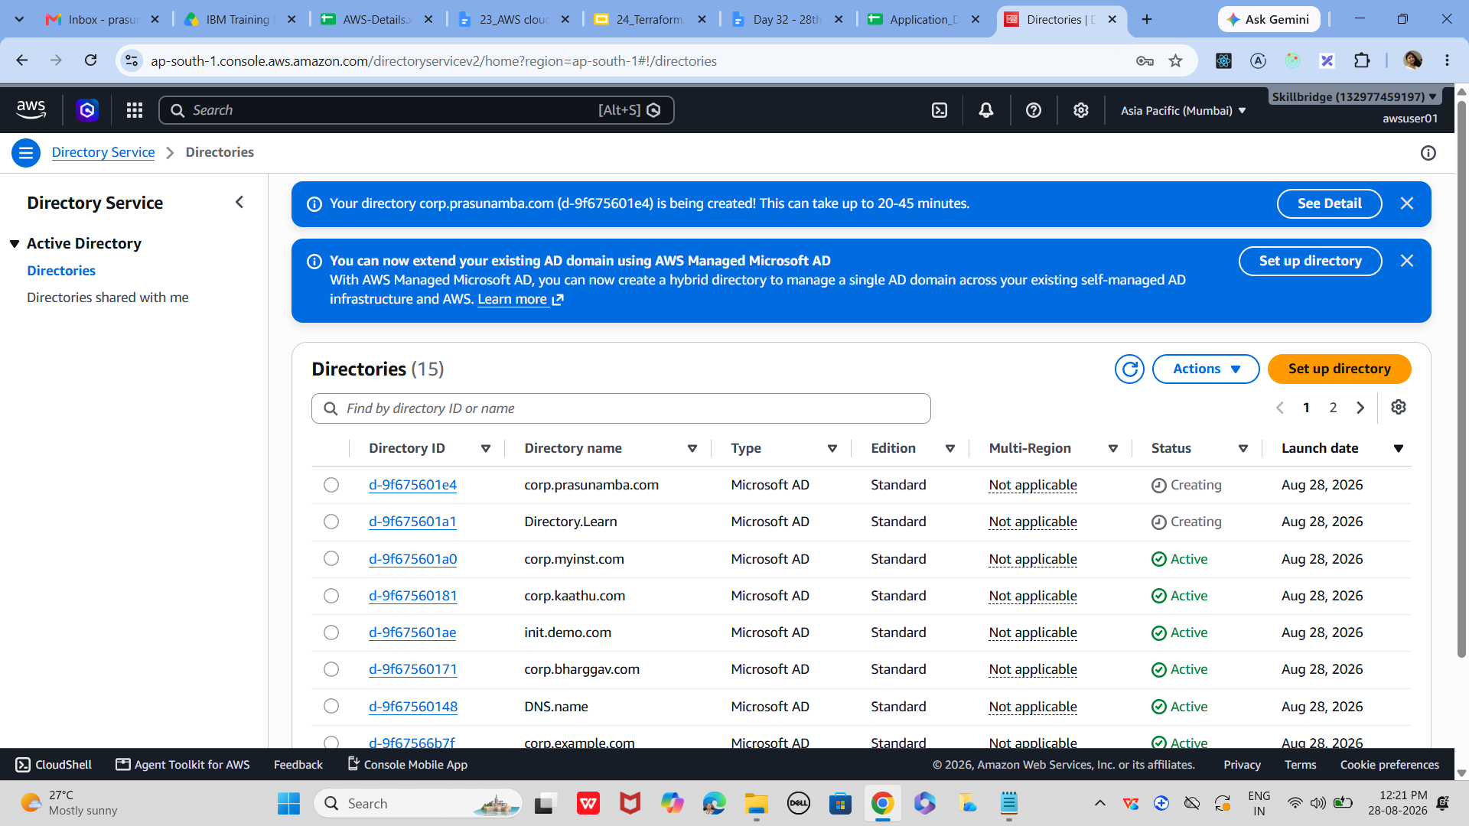

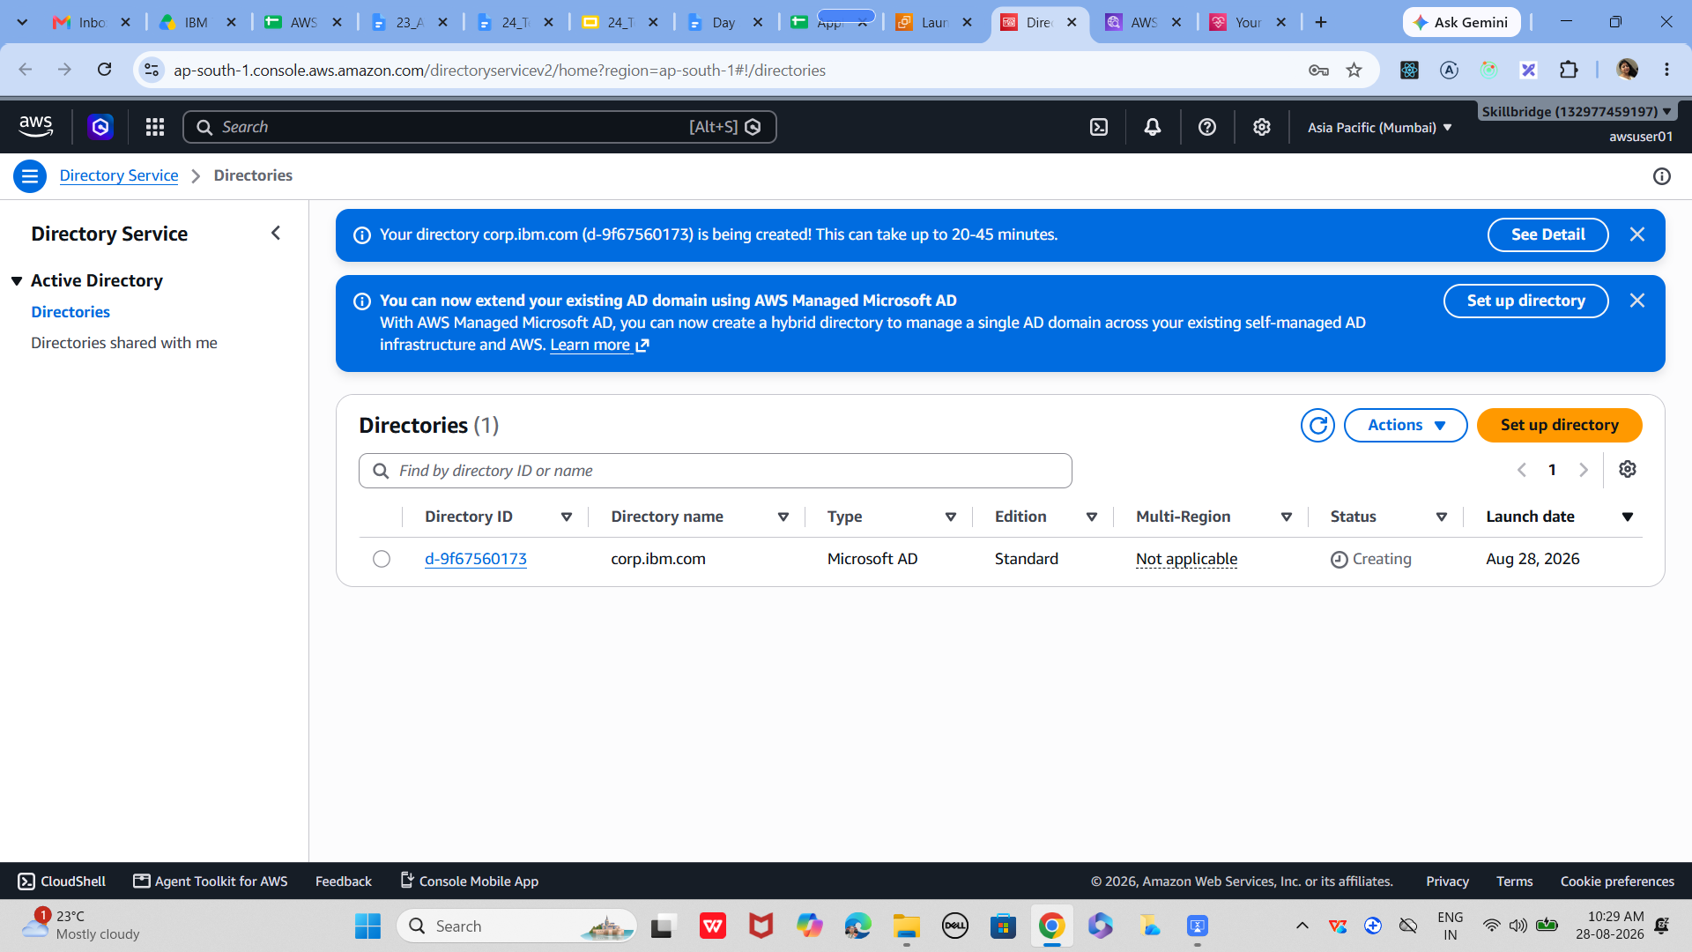

—-------------------------------------

Task 6: S3 bucket

01
Log in to AWS Console

Ensure you are in the correct region (top-right corner)

02
Open S3 Service
Navigate to the S3 dashboard where you can manage buckets.

In AWS Console → Search bar → Type 'S3' → Select S3

This opens the S3 home page

You’ll see a list of existing buckets if any you have any runing
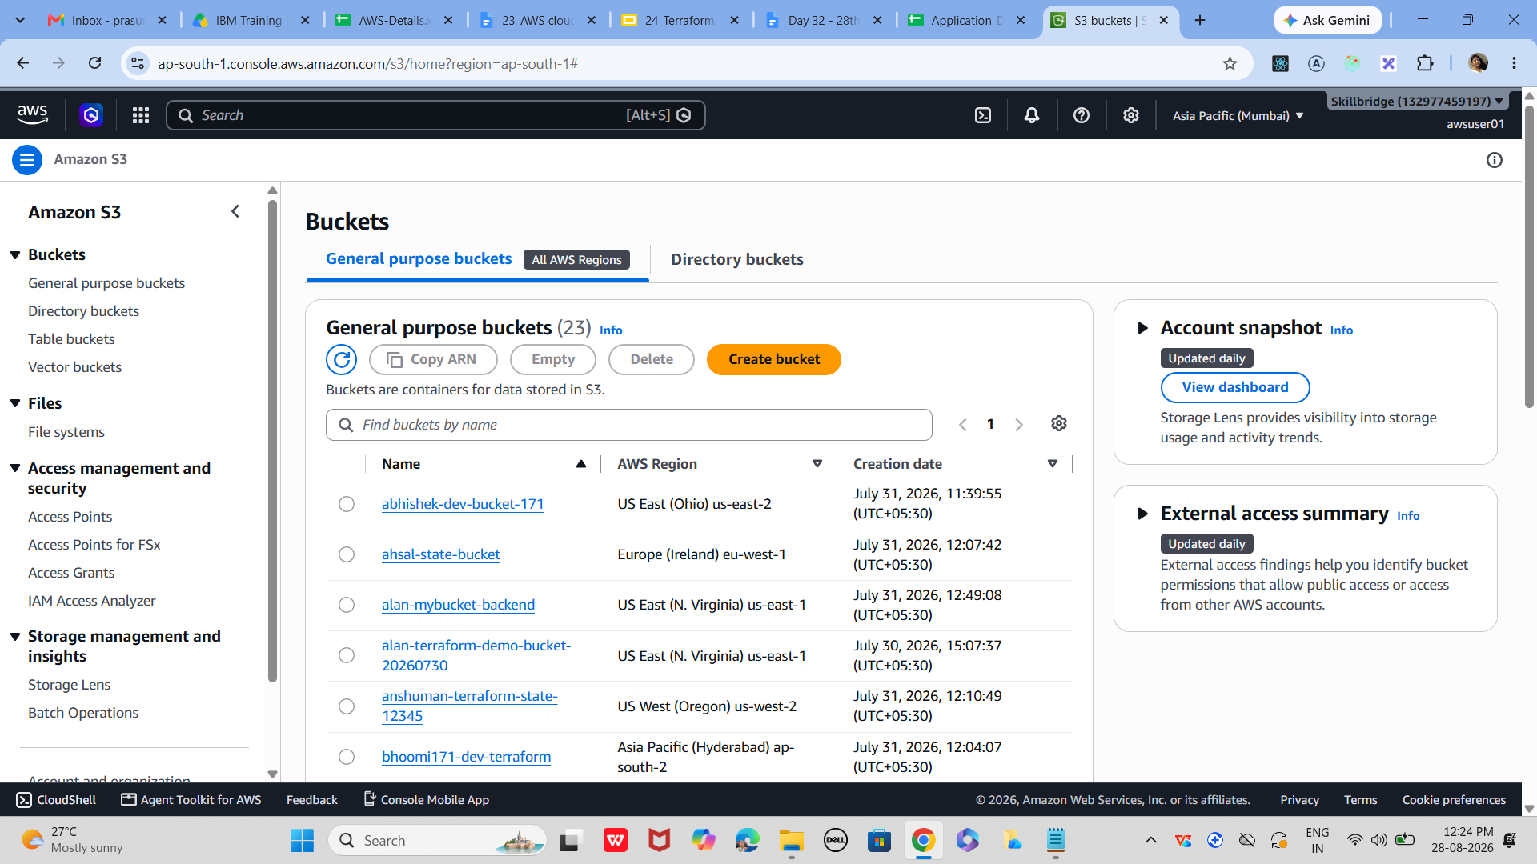

03
Create a New Bucket
Most Common Step
Buckets are the top-level containers in S3.

Click Create bucket

Enter a globally unique bucket name (e.g., Prasunamba-s3-demo)

Choose AWS Region (closer to your users for lower latency)

Leave defaults for demo

04
Configure Bucket Options
Set properties like versioning, encryption, and access control.

Enable versioning if you want to keep multiple versions of files

Choose encryption (SSE-S3 recommended)

Leave advanced settings default for beginners

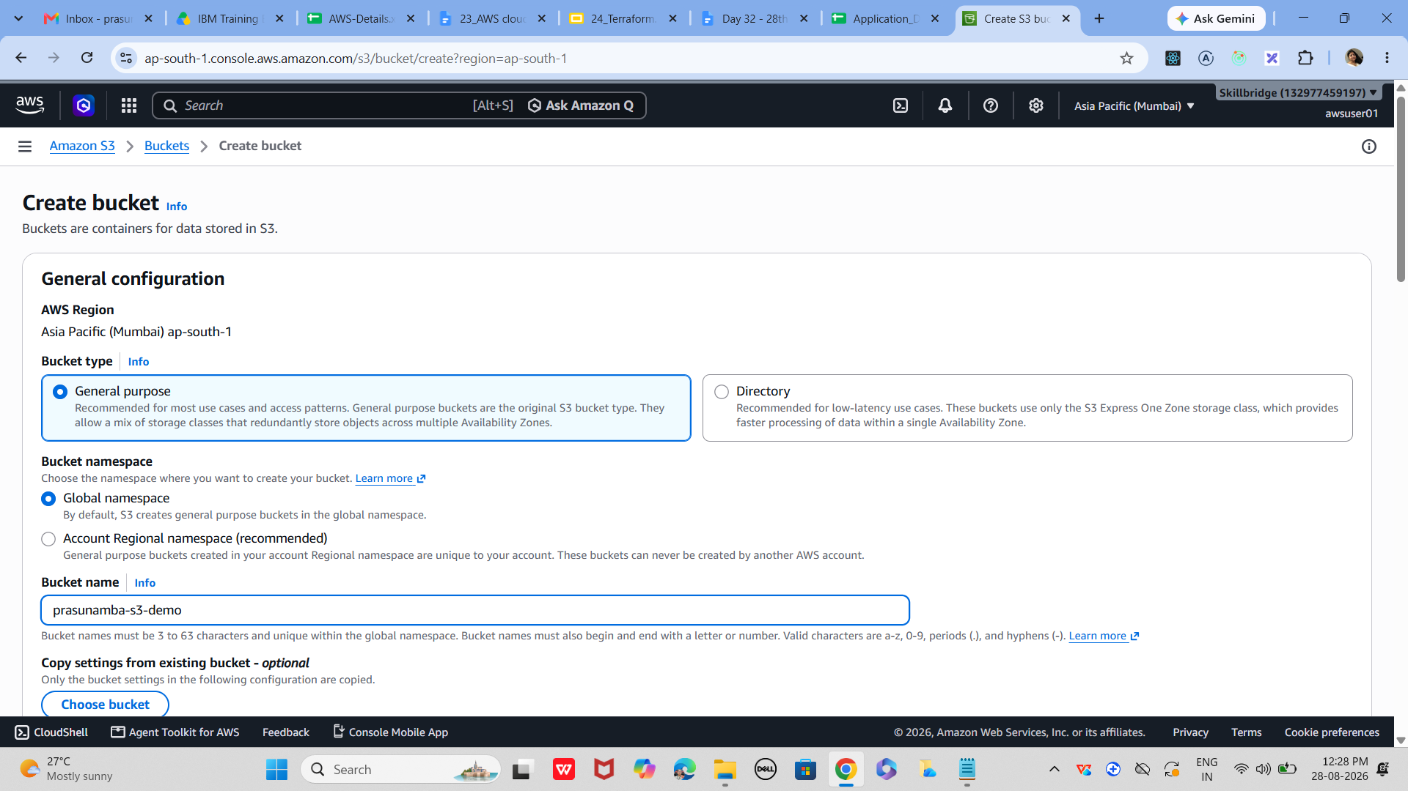

05
Set Permissions
Define who can access your bucket and objects.

By default, all buckets are private

Uncheck 'Block all public access' only if you want public files

For training/demo, keep it private

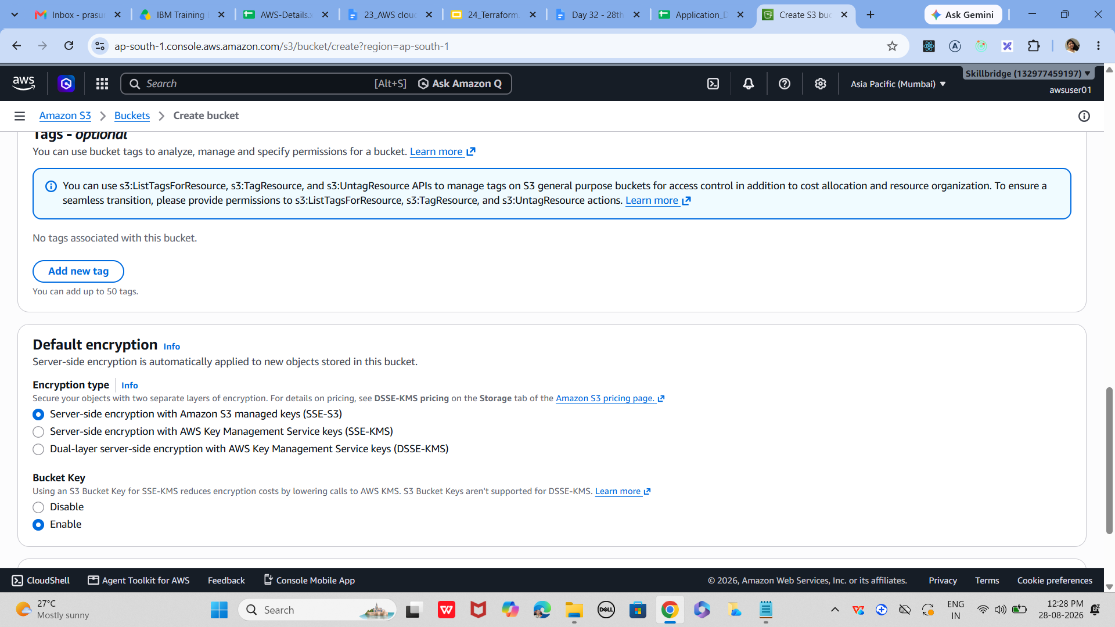

06
Upload Files
Add objects (files) to your bucket.

Open your bucket → Click Upload
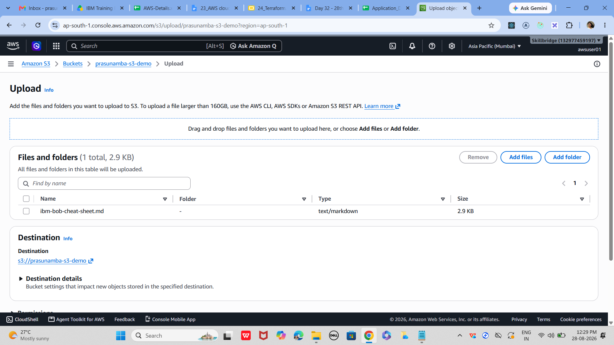

Drag and drop files or select from your computer

Click Upload to store them in S3
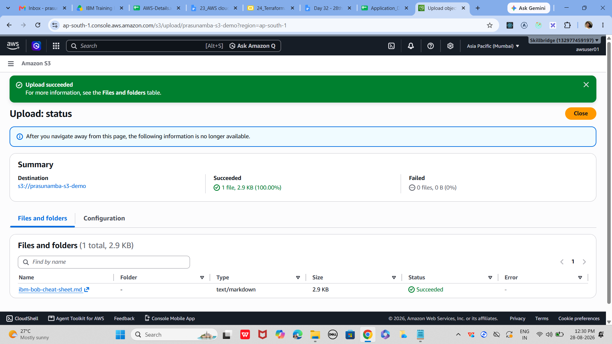

07
Verify and Access Objects
Confirm that files are uploaded and accessible.

Check object list inside bucket

Copy the object URL (works if permissions allow)

Use AWS CLI: aws s3 ls s3://my-first-s3-demo/

—------------------------------------

Task 7: IAM service

01
Open IAM Service
IAM is where you manage users, groups, and permissions.

Log in to AWS Console → Search for IAM in the Services menu

Click IAM to open the dashboard
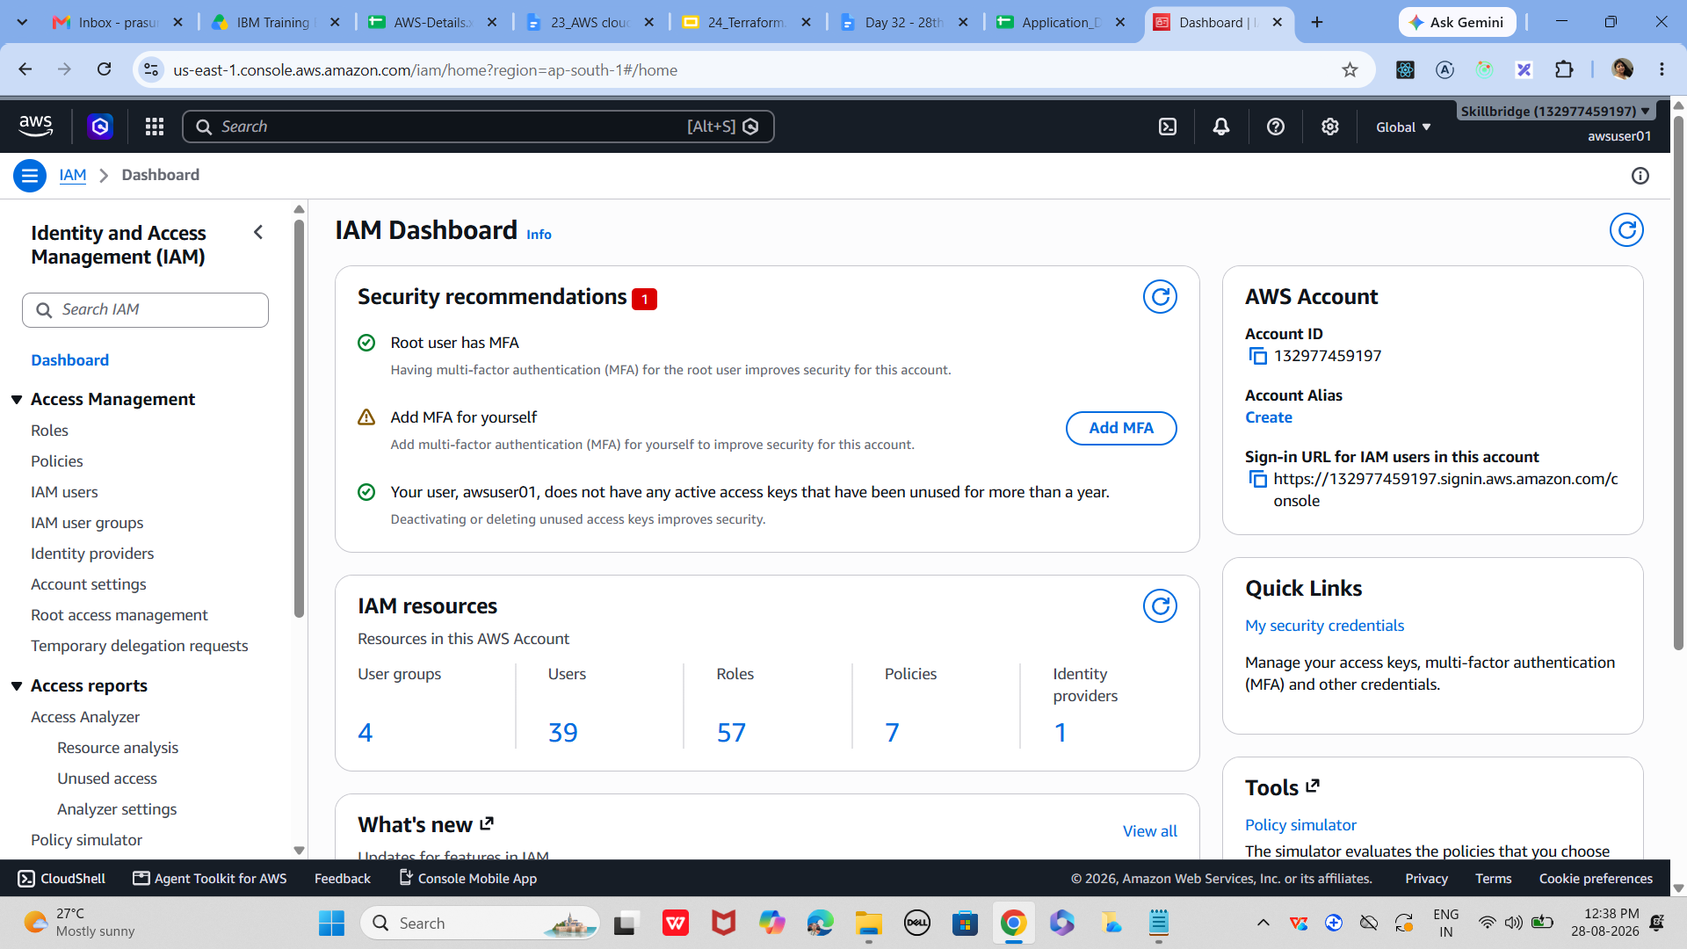

Review the summary: users, groups, roles, policies

In IAM users 👍
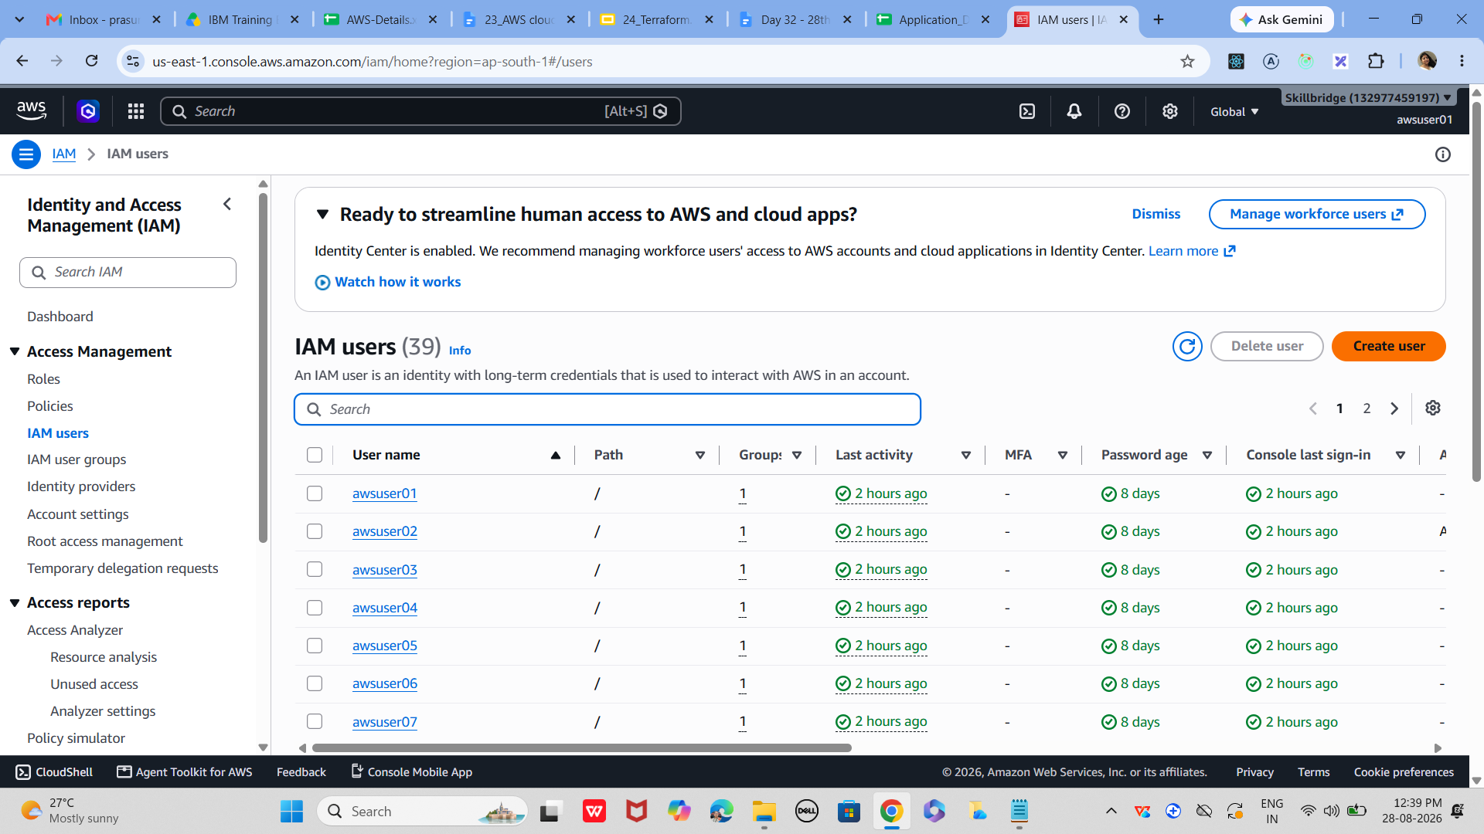

02
Create a New User like
Beginner Demo
Adding a user allows controlled access to AWS resources.

IAM Dashboard → Users → Add user

Enter a username (e.g., demo-user)

Select AWS Management Console access
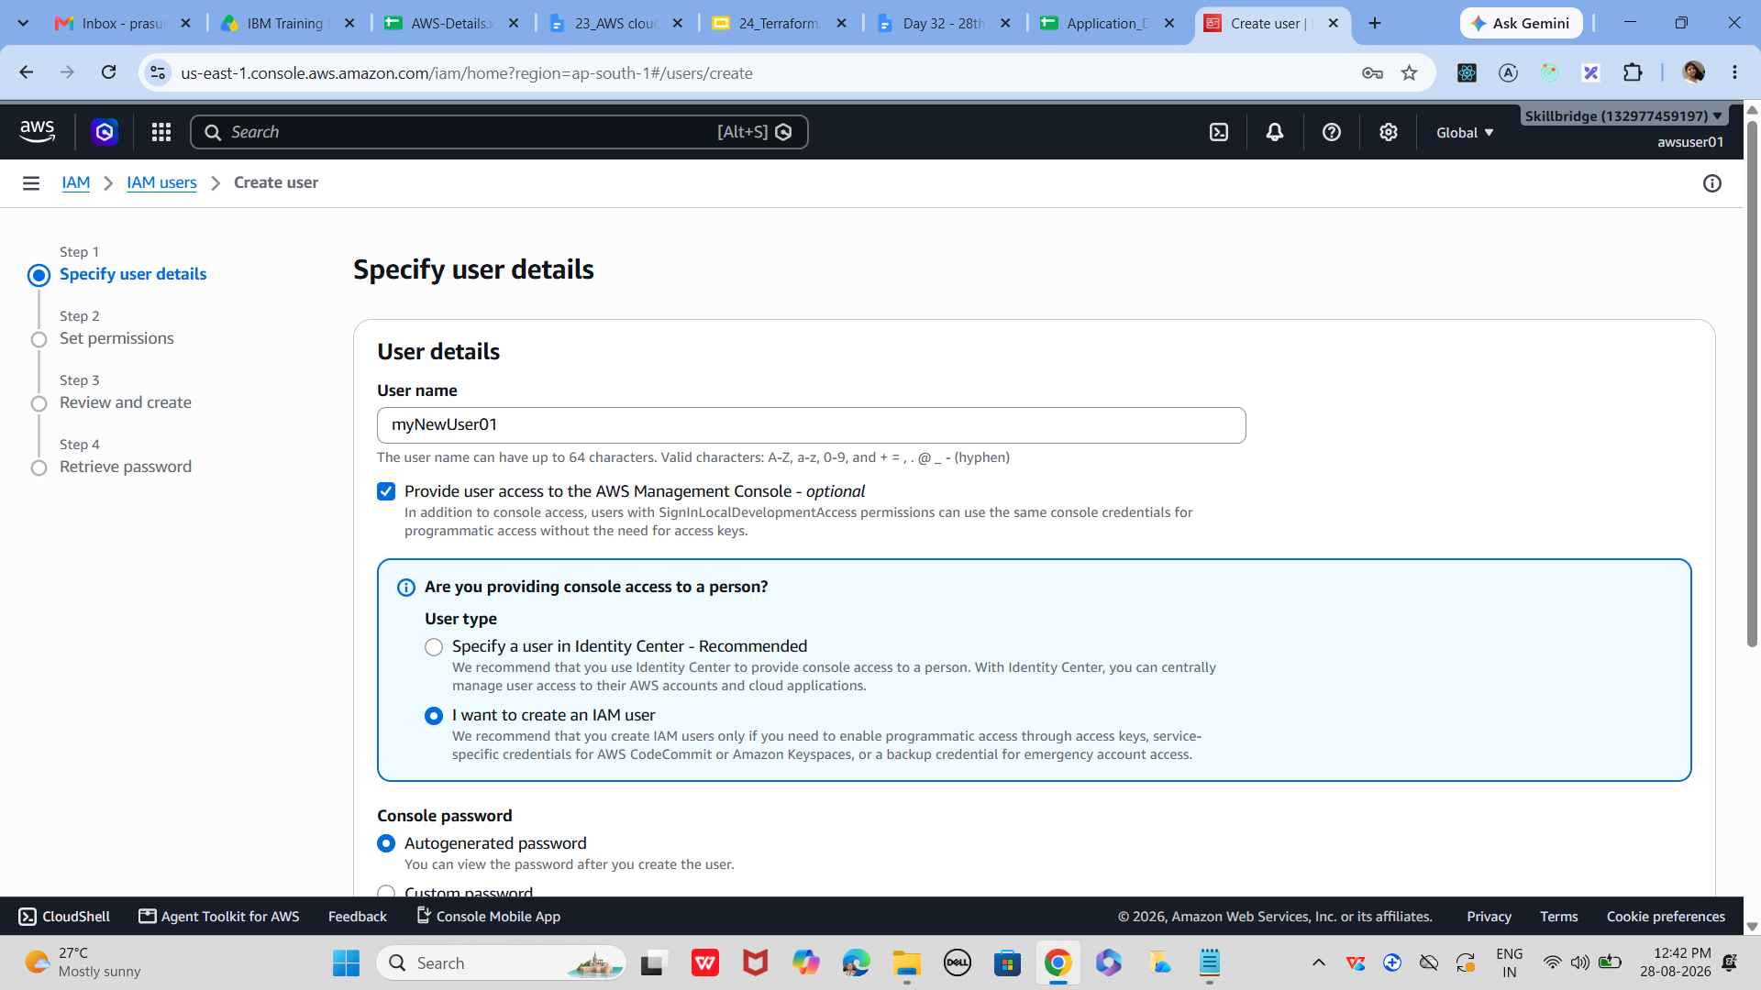

Set a custom password or auto-generate one

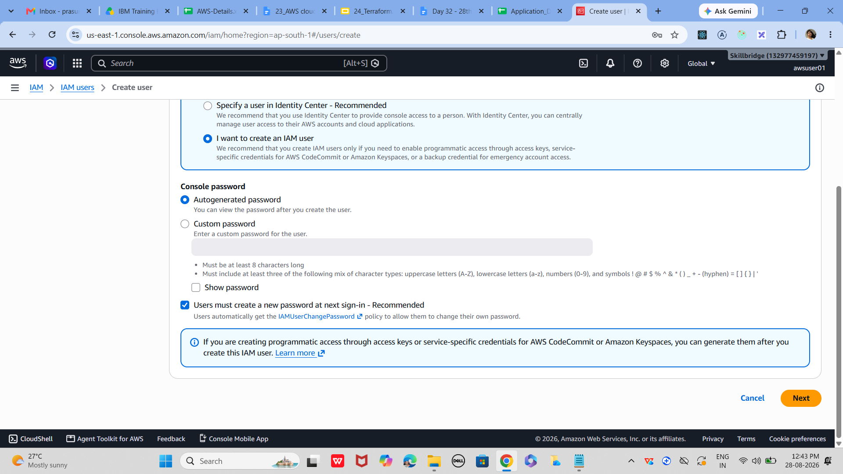

Require password reset on first login

03
now attach Permissions
Permissions define what the user can do.

Add user → Set permissions

Choose Attach existing policies directly

Select policy (e.g., AmazonS3ReadOnlyAccess)
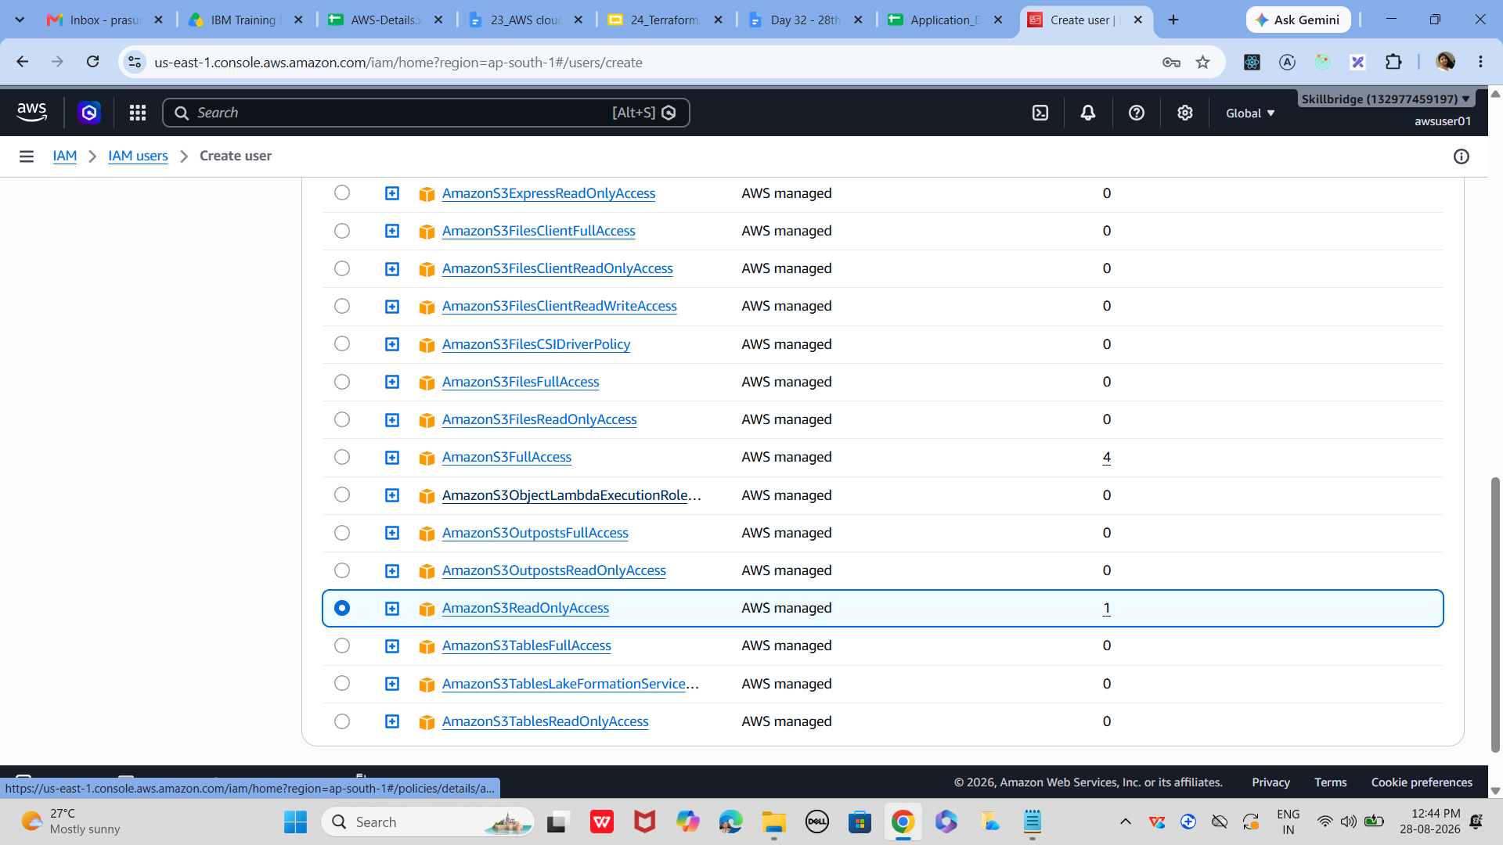
Alternatively, add user to a group with predefined policies

04
Review and Create User
Confirm settings before finalizing.
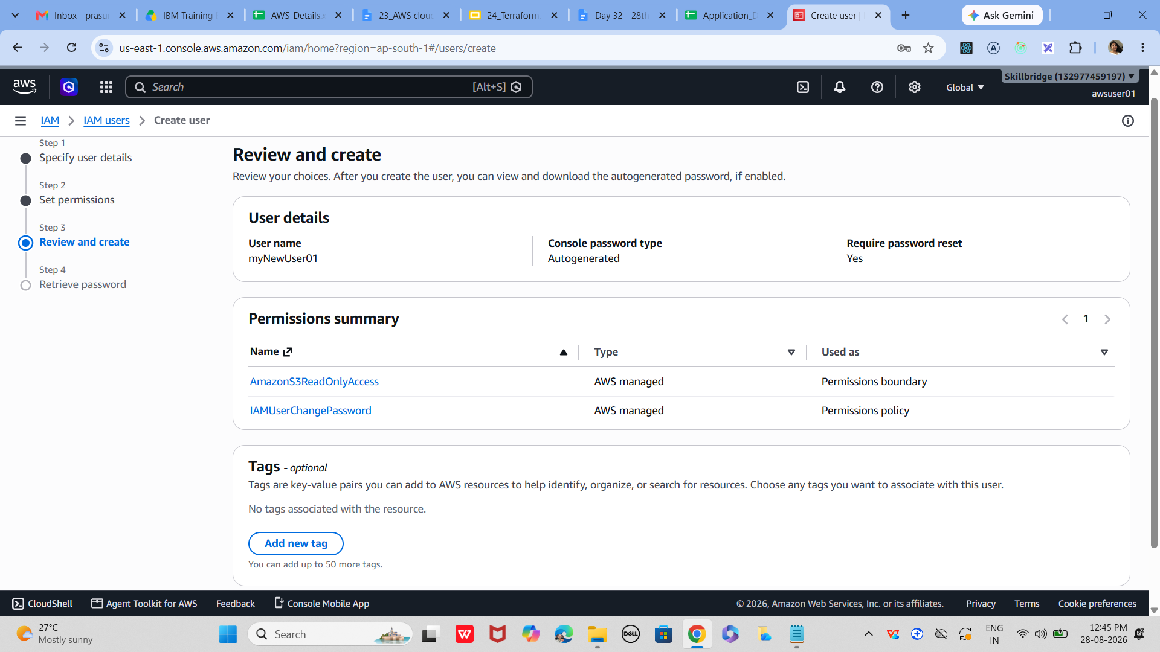
Add user → Review

Verify username and access type

Check assigned policies

Click Create user finally created user

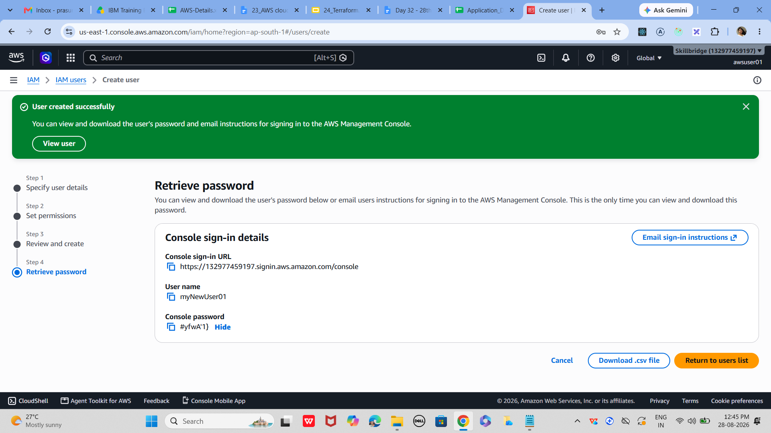

05
Test Login
Ensure the new user can access AWS with correct permissions.

Copy the login URL provided

Log in with the new username and password
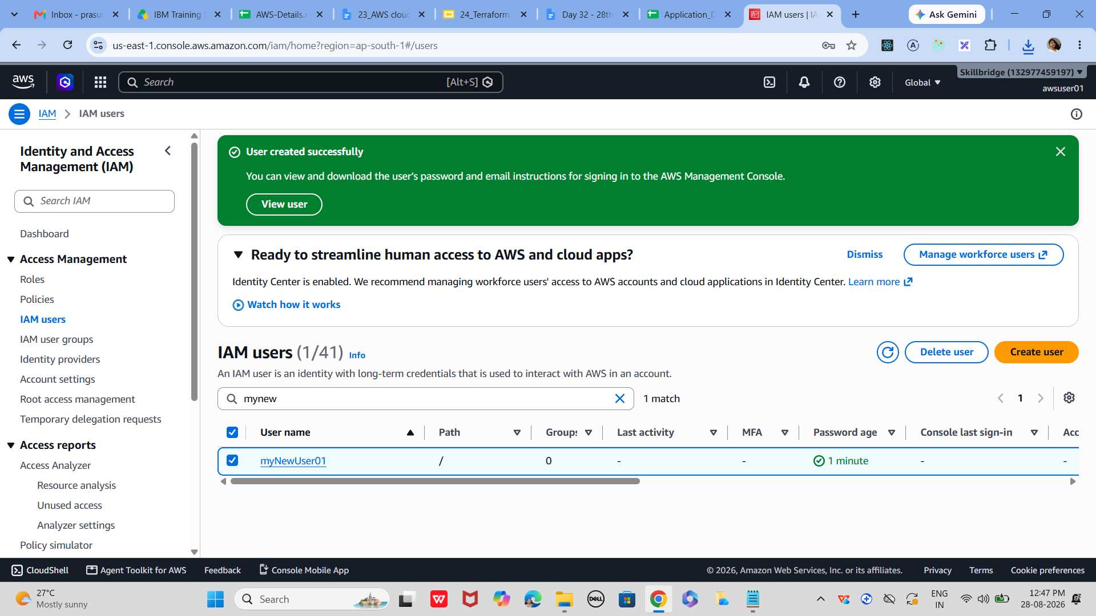
Verify access: try opening S3 (should be read-only)

Attempt restricted actions (e.g., EC2 launch) → should be denied

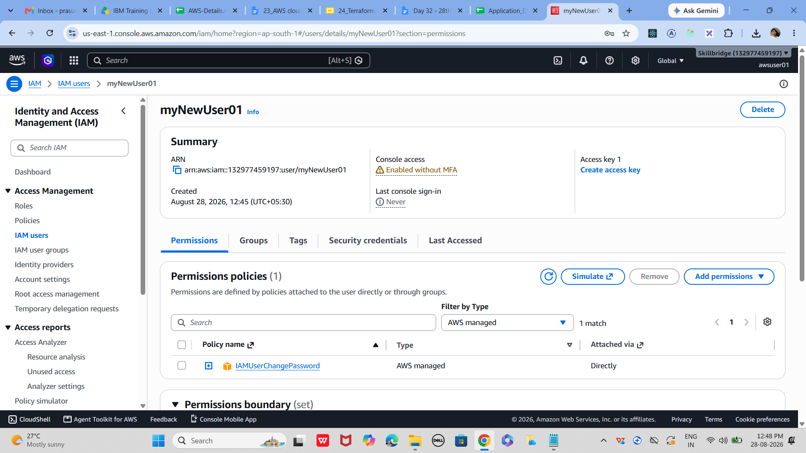

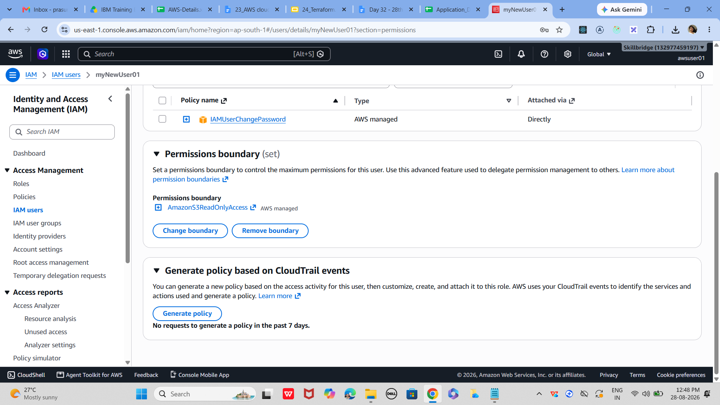
.

06
Create a Group (Optional)
Groups simplify permission management for multiple users.

IAM Dashboard → Groups → Create group

Name the group (e.g., Developers)

Attach policies (e.g., AmazonEC2FullAccess)

Add users to the group

07
Enable MFA for Security
Best Practice
Multi-Factor Authentication adds an extra security layer.

IAM Dashboard → Users → Select user → Security credentials

Click Assign MFA device

Choose virtual MFA (Google Authenticator, Authy)

Scan QR code → enter generated codes

Confirm setup
—-----------------------------

Task 8:

VPC (Virtual Private Cloud)
lets create a simple VPC with public and private subnets, an Internet Gateway, and routing rules.

01
Open the VPC Service
Start by accessing the AWS VPC dashboard.

AWS Console → Services → VPC

Log in to AWS Console

Search for VPC in the services menu

Click Your VPCs to begin setup

02
Create a New VPC
Define the core private network space.

Click Create VPC

Enter a name (e.g., DemoVPC)

Choose IPv4 CIDR block (e.g., 10.0.0.0/16)

Leave IPv6 optional for now

Click Create VPC

03
Add Subnets
Networking Basics
Divide the VPC into public and private subnets.

Go to Subnets → Create subnet

Select your VPC

Add a Public Subnet (e.g., 10.0.1.0/24)

Add a Private Subnet (e.g., 10.0.2.0/24)

Assign Availability Zones for redundancy

04
Attach an Internet Gateway
Enable internet access for resources in the public subnet.

Go to Internet Gateways → Create IGW

Name it (e.g., DemoIGW)

Attach it to your VPC

05
Configure Route Tables
Control traffic flow between subnets and the internet.

Go to Route Tables → Create route table

Associate with your VPC

Add route: 0.0.0.0/0 → Internet Gateway

Associate this route table with the Public Subnet

Keep Private Subnet route table without IGW

06
Test with an EC2 Instance
Verification
Launch an EC2 instance to confirm networking works.

Launch EC2 in Public Subnet

Assign a public IP

Connect via SSH to verify internet access

Launch EC2 in Private Subnet

Confirm it has no direct internet access

—------------------------------------------------------

Task 9:

Cli based practice 👍
Before you proceed
Aws configure
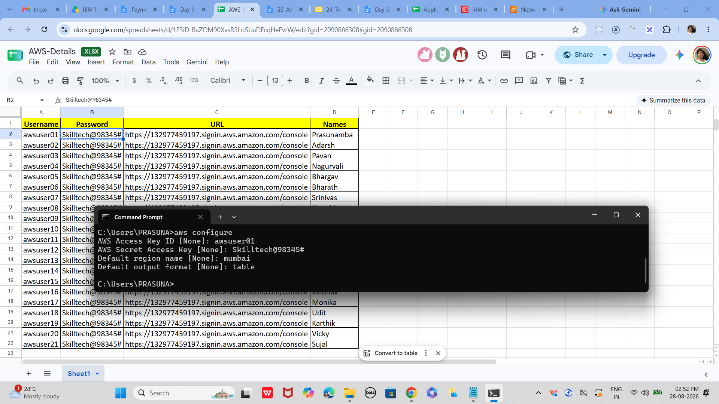

Aws configure list

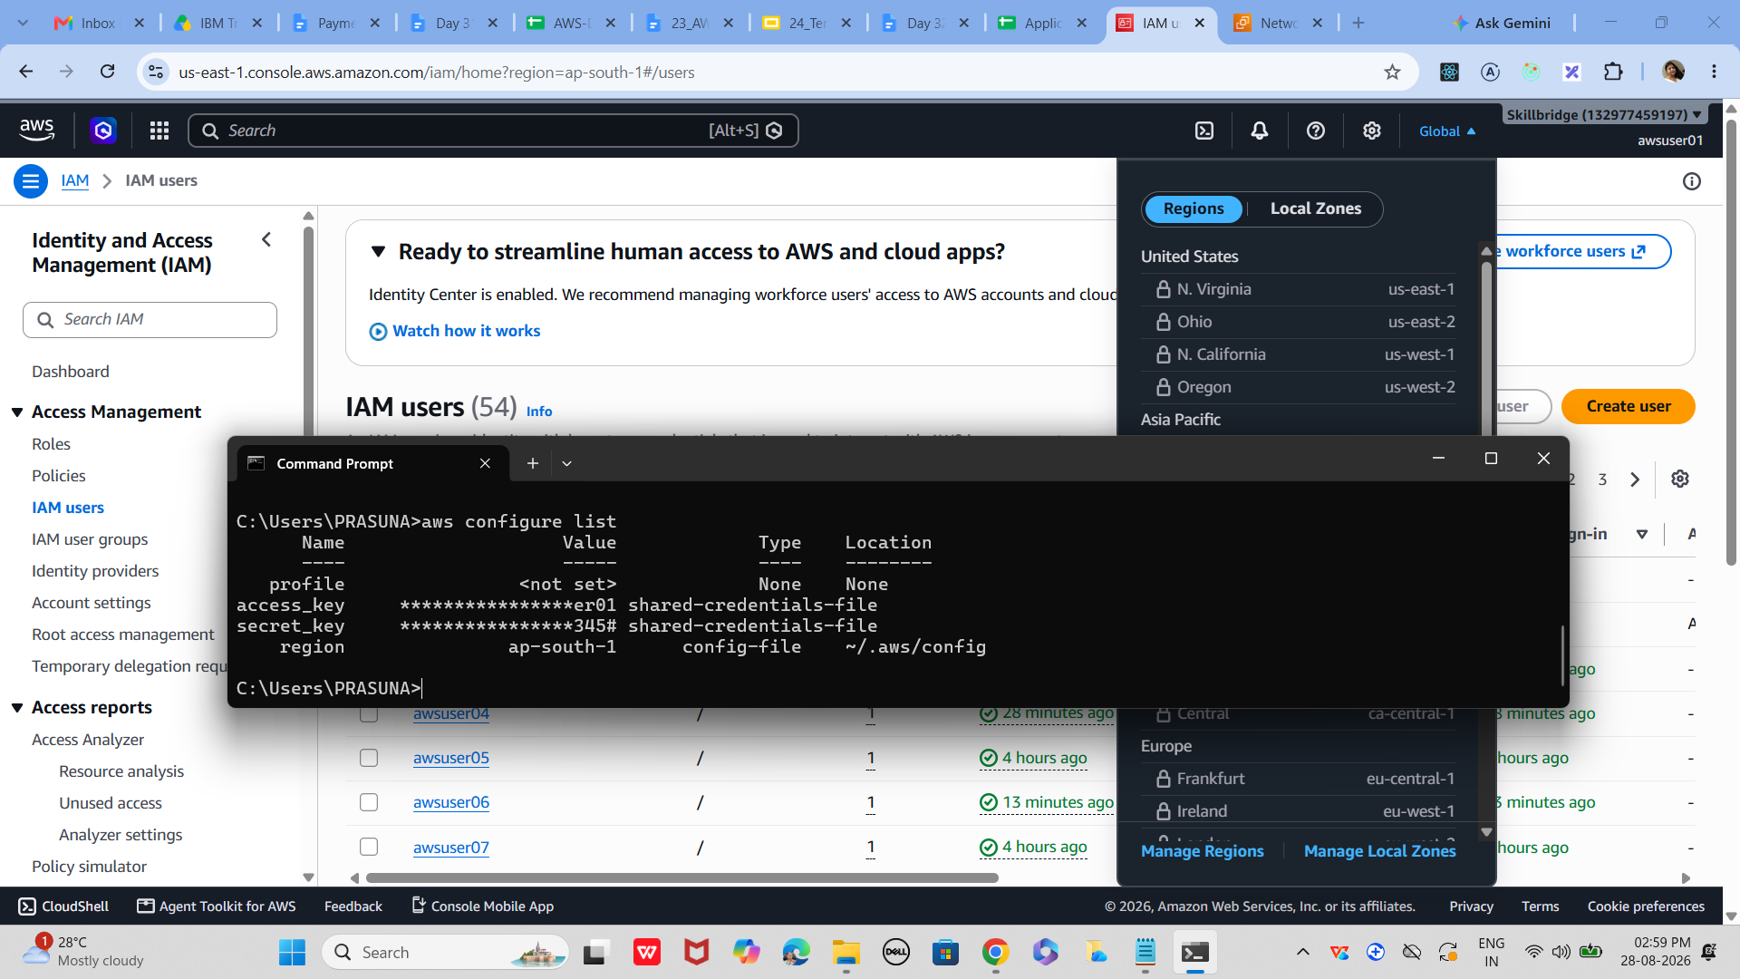

step 1:
Check AWS Global Infrastructure
List available regions and availability zones.

Run: aws ec2 describe-regions --output table

Run: aws ec2 describe-availability-zones --region us-east-1 --output table

Confirms which regions and zones you can use.

step 2:
Identity and Access Management (IAM)
Create a new IAM user with CLI.

Run: aws iam create-user --user-name demoUser

Attach policy: aws iam attach-user-policy --user-name demoUser --policy-arn arn:aws:iam::aws:policy/AmazonS3ReadOnlyAccess

Create login profile: aws iam create-login-profile --user-name demoUser --password <Password>

step 3:
Launch EC2 Instance
Start a basic compute server.

Run: aws ec2 run-instances --image-id ami-0abcdef1234567890 --count 1 --instance-type t2.micro --key-name myKey --security-group-ids sg-123456 --subnet-id subnet-123456

Check status: aws ec2 describe-instances --instance-ids <id>

step 4:
S3 Storage Basics
Create a bucket and upload a file.

Run: aws s3 mb s3://mybucket-demo

Upload: aws s3 cp demo.txt s3://mybucket-demo/

List: aws s3 ls s3://mybucket-demo/

step 5:
VPC Networking Basics
Create a simple VPC with subnets.

Run: aws ec2 create-vpc --cidr-block 10.0.0.0/16

Create subnet: aws ec2 create-subnet --vpc-id <vpc-id> --cidr-block 10.0.1.0/24

Create IGW: aws ec2 create-internet-gateway

Attach IGW: aws ec2 attach-internet-gateway --vpc-id <vpc-id> --internet-gateway-id <igw-id>

step 6:
RDS Managed Database
Launch a MySQL RDS instance.

Run: aws rds create-db-instance --db-instance-identifier mydb --db-instance-class db.t2.micro --engine mysql --master-username admin --master-user-password <Password> --allocated-storage 20

Check status: aws rds describe-db-instances --db-instance-identifier mydb

step 7:
Security Groups Basics
Configure inbound rules for EC2.

Run: aws ec2 create-security-group --group-name demoSG --description "Demo SG" --vpc-id <vpc-id>

Add rule: aws ec2 authorize-security-group-ingress --group-id <sg-id> --protocol tcp --port 22 --cidr <your-ip>/32
Verify: aws ec2 describe-security-groups --group-ids <sg-id>
—-----------------------------------------------------------------------------------------------------------------------------------------------------------------------------------------------------------------

Creating access key:

IN AWS CONSOLE
Go to IAM → Users → [Your IAM user] → Security credentials.

